2014年普通高等学校招生全国统一考试新课标2卷
英 语
本试卷分第I卷（选择题）和第II卷（非选择题）两部分。考试结束后，将本试卷和答案卡一并交回。
注意事项：
1．答第I卷前考生务必将自己的姓名、准考证号填写在答题卡上。
2．选出每小题答案前，用2B铅笔把答题卡上对应题目的答案标号涂黑。如需改动,用橡皮擦干净后,再选涂其他答案标号框,不能答在本试卷上，否则无效。
第一部分 阅读理解（共两节，满分40分）
第一节 (共15小题；每小题2分，满分40分)
阅读下列列短文，从每题所给的四个选项(A、B、C和D)中,选出最佳选项。并在答题卡上将该选项涂黑．
A
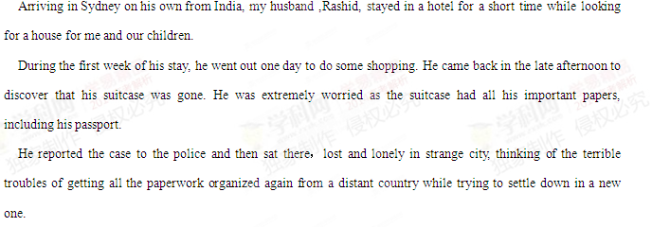 Late in the evening, the phone rang. It was a stranger. He was trying to pronounce my husband’s name and was asking him a lot of questions. Then he said they had found a pile of papers in their trash can（垃圾桶）that had been left out on the footpath.
My husband rushed to their home to find a kind family holding all his papers and documents. Their young daughter had gone to the trash can and found a pile of unfamiliar papers. Her parents had carefully sorted them out, although they had found mainly foreign addresses on most of the documents. At last they had seen a half-written letter in the pile in which my husband had given his new telephone number to a friend.
That family not only restored the important documents to us that day but also restored our faith and trust in people.We still remember their kindness and often send a warm wish their way.

【小题1】.What did Rashid plan to do after his arrival in Sydney?
A.Go shopping
B.Find a house
C.Join his family
D.Take his family
【小题2】.The girl’s parents got Rashid’s phone number from_______.
A.a friend of his family
B.a Sydney policeman
C.a letter in his papes
D.a stranger in Sydney
【小题3】.What does the underlined word“restored”in the last paragraph mean?
A.Showed
B.Sent out
C.Delivered
D.Gave back
【小题4】.Which of the following can be the best title for the text?
A.From India to Australia.
B.Living in a a New Country.
C.Turning Trash to Treasure.
D.In Search of New Friends.
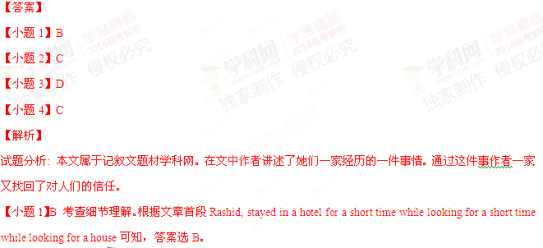B
【题文】Since the first Earth Day in 1970,American have gotten a lot “greenter” toward the environment . “We didn’t know at that time there even was an environment,let alone that there was a problem with it,”says Bruce Anderson,president of Earth Day USA.
But what began as nothing important in public affairs has grown into a social movement .Business people,political leaders, university professors,and especially millions of grass-roots Americans are taking part in the movement. “The understanding has increased many ,many times,”says Gaylord Nelson,the fromer govermor from Wisconsin,who thought up the first According to US government reports , emissions (排放)from cars and trucks have dropped from 10.3 million tons a year to 5.5 tons .The number of cities producing CO beyond the standard has been reduced from 40 to 9 .Although serious problems still remain and need to be dealt with , the world is a safer and healthier place .A kind of “Green thinking ” has become part of practices .
Great improvement has been achieved .In 1988 there were only 600 recycling programs ,; today in 1995 there are about 6,600 .Advanced lights ,motors , and building designs have helped save a lot of energy and therefore prevented pollution .
Twenty –five years ago , there were hardly any education programs for environment .Today , it’s hard to find a public school , university , or law school that does not have such a kind of program .” Until we do that , nothing else will change! ” say Bruce Anderson .
【小题1】 According to Anderson , before 1970, Americans had little idea about ___
A the social movement
B recycling techniques
C environmental problems
D the importance of Earth Day
【小题2】Where does the support for environmental protection mainly come from?
A The grass –roots level
B The business circle
C Government officials
D University professors
【小题3】What have Americans achieved in environmental protection ?
A They have cut car emissions to the lowest
B They have settled their environmental problems
C They have lowered their CO levels in forty cities.
D They have reduced pollution through effective measures .
【小题4】.What is especially important for environmental protection according to the last paragraph ?
A Education
B Planning
C Green living
D CO reduction
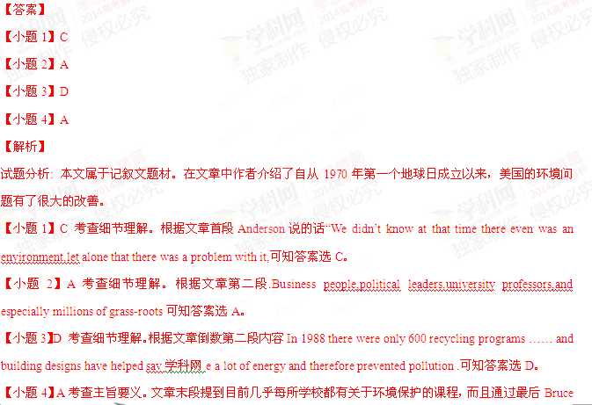Anderson说的话“Until we do that , nothing else will change! ”可知答案选A。
考点：考查社会生活类短文阅读。
【结束】
C
【题文】 One of the latest trend（趋势） in American Childcare is Chinese au pairs. Au Pair in Stamford, for example, has got increasing numbers of request for Chinese au pairs from aero to around 4,000 since 2004. And that’s true all across the country.
“I thought it would be useful for him to learn Chinese at an early age” Joseph Stocke, the managing director of s company, says of his 2-year old son. “I would at least like to give him the chance to use the language in the future,” After only six months of being cared by 25-year-old woman from China, the boy can already understand basic Chinese daily expressions, his dad says.
Li Drake, a Chinese native raising two children in Minnesota with an American husband, had another reason for looking for an au pair from China. She didn’t want her children to miss out on their roots.” Because I am Chinese, my husband and I wanted the children to keep exposed to(接触) the language and culture.” she says.
“Staying with a native speaker is better for children than simply sitting in a classroom,” says Suzanne Flynn, a professor in language education of Children.”But parents must understand that just one year with au pair is unlikely to produce wonders. Complete mastery demands continued learning until the age of 10 or 12.”
The popularity if au pairs from china has been strengthened by the increasing numbers of American parents who want their children who want their children to learn Chinese. It is expected that American demand for au pairs will continue to rise in the next few years.
【小题1】.What does that term” au pair” in the text mean?
A. A mother raising her children on her own
B. A child learning a foreign language at home
C. A professor in language education of children
D. A young foreign woman taking care of children.
【小题2】. Li Drake has her children study Chinese because she wants them ______.
A. to live in China some day
B. to speak the language at home
C. to catch up wit other children
D. to learn about the Chinese culture
【小题3】. What can we infer from the text?
A. Learning Chinese is becoming popular In America,
B. Educated woman do better in looking after children
C. Chinese au pairs need to improve their English Skills.
D. Children can learn a foreign language well in six months.
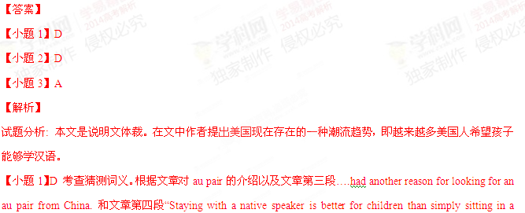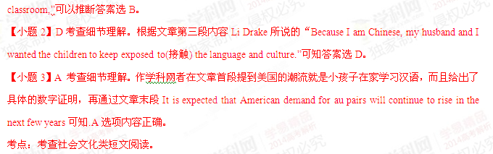【结束】
D
Metro Pocket Guide
【题文】Metrorall (地铁)
Each passenger needs a farecard to enter and go out .Up to two children under age five may travel
Free with a paying customer .
Farecard machines are in every station .Bring small bills because there are no change machines in the stations and farecard machines only provide up to $5 in change.
Get one ticket of unlimited Metrorall rides with a One Day Pass .Buy it from a farecard machine in Metro stations .Use it after 9:30 a,m. until closing on weekdays , and all day on weekends and holidays .
Hours of service
Open 5am Mon-Fri 7a.m Sat-Sun
Open midnight Sun-Thur.
Last train times vary .
Train times Posted in stations
Metrobus
When paying with exact charge , the fare is $1.35.When paying with a SmarTripⓇcard , the fare is
1.25.
Fares
Senior citizens 65 and older and disabled customers may ride for half the regular fare .On Metrorail and Metrobus , use a senior/disabled farecard or Smar/Trip Ⓡ card .For more information about buying senior .disabled farecard , SmarTripⓇcards and passes , please visit MetroOpensDoors .com or call 202-637-7000and 202-637-8000.
Senior citizens and disabled customers can get free guide on how to use proper Metrobus and Metrorall services by calling 202-962-1100.
Travel tips (提示)
. Avoid riding during weekday rush periods –before 9:30 a.m. and between 4and 6p.m.
. If you lose something on a bus or train or in a station, please call Lost &Found at 202-962-1195,
32. What should you know about farecard machines?
A. They start selling tickets at 9:30 a.m.
B. They are connected to change machines .
C. They offer special service to the elderly .
D. They make change for no more than $5.
33.At what time does Metroarll stop service on Saturday ?
A. At midnight .
B. At 3 a.m.
C. At 5 a.m.
D. At 7a.m.
34. What is good about a SmarTripⓇcard ?
A. It is convenient for old people .
B. It saves money for its users
C It can be bought at any train
D. It is sold on the Internet
35.Which number should you call if you lose something on the Metro?
A.202-962-1195
B.202-962-1100
C.202-637-7000
D.202-637-8000
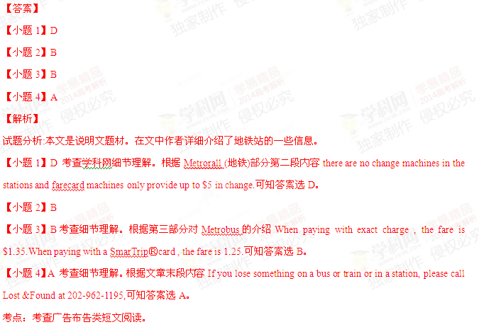【结束】
第二节（共5小题：每小题2分，满分10分）
【题文】根据短文内容， 从短文后的选项中选出能填入空白处的最佳选项。选项中有两项为多余选项。

Tips for Cooking on a Tight Schedule
From my experience , there are three main reasons why people don’t cook more often :ability , money , and time 36 .Money is a topic I’ll save for another day .So today I want to give you some wisdom about how to make the most of the time you spent in the kitchen .Here are three tips for great cooking on a tight schedule :
- Think ahead .The moments when I think cooking is a pain are when I’m already hungry and there’s nothing ready to eat .So think ahead of the coming week .When will you have time to cook ?Do you have the right materials already ? 37 .
- Make your time worth it .When you do find time to cook a meal , make the most of it and save yourself time later on .Are you making one loaf of bread ? 38 .It takes around the same amount of time to make more of something .So save yourself the effort for future meal .
- 39 This may surprise you , but one of the best tools for making cooking worth your time is experimentation .It gives you the chance to hit upon new ideas and recipes that can work well with your appetite and schedule. The more you learn and the more you try, the more ability you have to take control of your food and your schedule.
Hopefully that gives you a good start. 40_______ And don’t let a busy schedule discourage you from making some great changes in the way you eat and live!

A. Try new things.
B. Ability is easily improved.
C. Make three or four instead.
D. Understand your food better.
E. Cooking is a burden for many people.
F. Let cooking and living simply be a joy rather than a burden.
G. A little time planning ahead can save a lot of work later on.
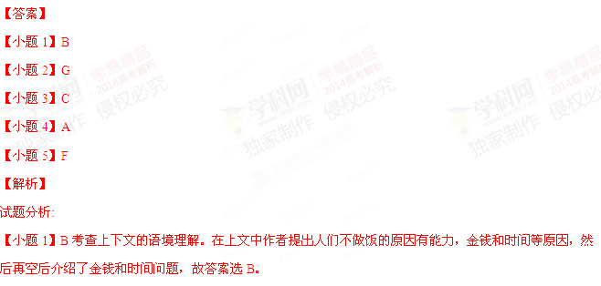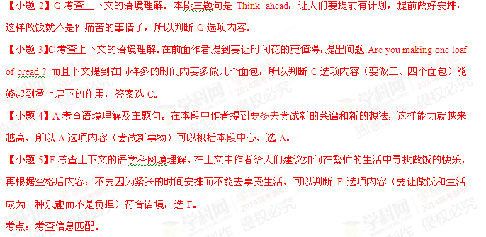【结束】

第二部分 英语知识运用（共两节，满分45分）
第一节 完形填空（共20小题；每题1.5分，满分30分）
【题文】 阅读下面短文，从短文后各题所给的四个选项（A, B, C和D）中，选出可以填入空白处的最佳选项，并在答题卡上将该项涂黑。
Joe Simpson and Simon Yates were the first people to climb the West Face of the Siula Grande in the Andes mountains. They reached the top 21_______, but on their way back conditions were very 22_______. Joe fell and broke his leg. They both knew that if Simon 23_______ alone, he would probably get back 24_______. But Simon decided to risk his 25_______ and try to lower Joe down the mountain on a rope（绳）.
As they 26_______ down, the weather got worse. Then another 27_______ occurred. They couldn’t see or hear each other and, 28_______, Simon lowered his friend over the edge of a precipice（峭壁）. It was 29_______ for Joe to climb back or for Simon to pull him up. Joe’s 30_______ was pulling Simon slowly towards the precipice. 31_______, after more than an hour in the dark and the icy cold, Simon had to 32_______. In tears, he cut the rope. Joe 33_______ into a large crevasse（裂缝）in the ice below. He had no food or water and he was in terrible pain. He couldn’t walk, but he 34_______ to get out of the crevasse and started to 35_______ towards their camp, nearly ten kilometers 36_______.
Simon had 37_______ the camp at the foot of the mountain. He thought that Joe must be 38_______, but he didn’t want to leave 39_______. Three days later, in the middle of the night, he heard Joe’s voice. He couldn’t 40_______ it. Joe was there, a few meters from their tent, still alive.
【小题1】. A. hurriedly B. carefully C. successfully D. early
【小题2】. A. difficult B. similar C. special D. normal
【小题3】.A.climbed B. worked C. rested D. continued
【小题4】A. unwillingly B. safely C. slowly D. regretfully
【小题5】A. fortune B. time C. health D. life
【小题6】A. lay B. settled C. went D. looked
【小题7】A. damage B. storm C. change D. trouble
【小题8】 A. by mistake B. by chance C. D.
【小题9】 A. unnecessary B. practical C. important D. impossible
【小题10】 A. height B. weight C. strength D. equipment
【小题11】 A. Finally B. Patiently C Surely D Quickly
【小题12】.A stand back B take a rest C make a decision D hold on
【小题13】.A jumped B. fell C escaped D backed
【小题14】. A. managed B. planned C. waited D. hoped
【小题15】 A. run B. skate C. move D. march
【小题16】A. around B. away C. above D. along
【小题17】A. headed for B .traveled to C. left for D. returned to
【小题18】A. dead B .hurt C. weak D. late
【小题19 A. secretly B. tiredly C. immediately D. anxiously
【小题20】A. find B. believe C. make D. accept

【小题7】D
【小题8】A
【小题9】D
【小题10】B
【小题11】A
【小题12】C
【小题13】B
【小题14】A
【小题15】C
【小题16】B
【小题17】D
【小题18】A
【小题19】C
【小题20】B
【解析】
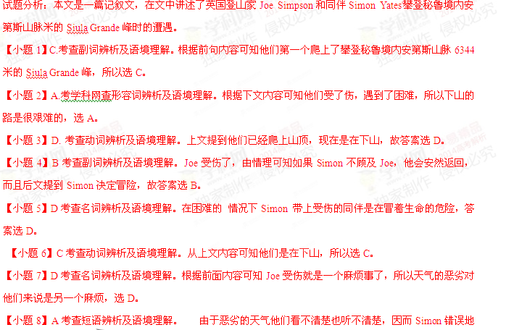把Joe用绳子放到了悬崖边，答案选A。
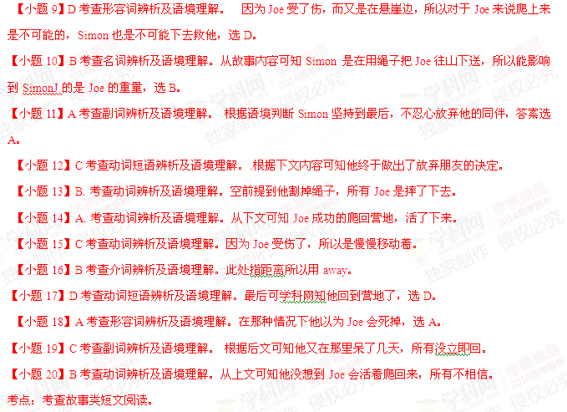【结束】
第二卷
注意：将答案写在答题卡上。写在本试卷上无效。
第三部分 英语知识运用（共两节，满分45分）
第二节（共10小题：每小题1.5分，满分15分）
阅读下面材料，在空白处填入适当的内容（不多于3个单词）或括号内单词的正确形式。
One morning , I was waiting at the bus stop , worried about 61 (be ) late for school ..There were many people waiting at the bus stop , 62 some of them looked very anxious and 63 (disappoint) .When the bus finally came , we all hurried on board .I got a place next 64 the window , so I had a good view of the sidewalk .A boy on a bike 65 (catch)my attention .he was riding beside the bus and waving his arms . I heard a passenger behind me shouting to the driver , but he refused 66 (stop ) until we reached the next stop .Still , the boy kept 67 (ride) . He was carrying something over his shoulder and shouting .Finally , when we came to the next stop , the boy ran up to the door of the bus . I heard an excited conversation .Then the driver stoop up and asked, “ 68 anyone lose a suitcase at the last stop ?” A woman on the bus shouted , “Oh dear “ It is 69 （I）”.She pushed her way to the driver and to the little boy .Everyone on the bus began talking about what the boy had done .And the passengers _70_（sudden） became friendly to one another .
【答案】
【小题1】being
【小题2】and
【小题3】disappointed
【小题4】to
【小题5】caught
【小题6】to stop
【小题7】riding
【小题8】Did
【小题9】me /mine
【小题10】suddenly
【解析】
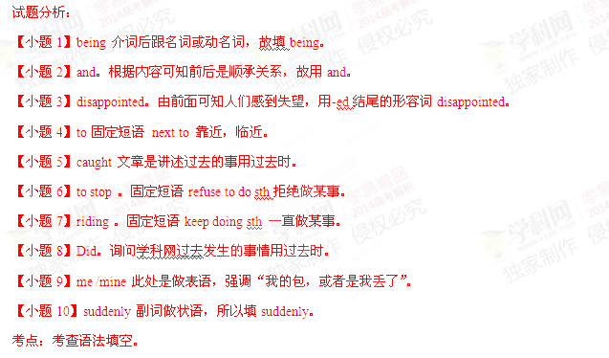【结束】
第四部分 写作（共两节，满分35分）
- 短文改错（共10小题；每小题1分，满分10分）
【题文】假定英语课上老师要求同桌之间交换修改作文，请你修改你同桌写的以下作文。文中共有10处错误，每句中最多有两处，每处仅涉及一个单词的增加、删除或修改。
增加：在缺词处加一个漏字符号（^），并在其下面写出该加的词。
删除：把多余的词用斜线（\）划掉。
注意：1. 每处错误及其修改均仅限一词；
2. 只允许修改10处，多者（从第11处起）不计分。
My dream school starts at 8:30 a.m. and ends at 3:30 p.m. They are three lessons in the morning and two in the afternoon .We didn’t need to do so many homework .Therefore , we have more time with after-school activities .For example , we can do reading for one and a half hour and play sports for one hour every day .
My dream school look like a big garden .There are all kinds of the flowers and trees around the classroom buildings .We can lie on the grass for a rest , or sat by the lake listening music .The teachers here are kind and helpfully .They are not only our teachers but also our friends .
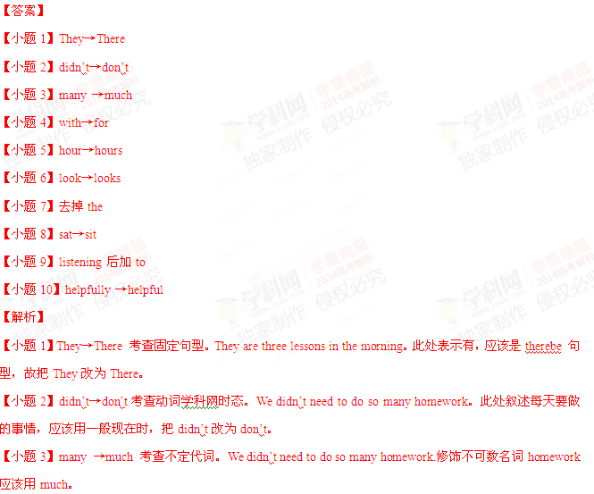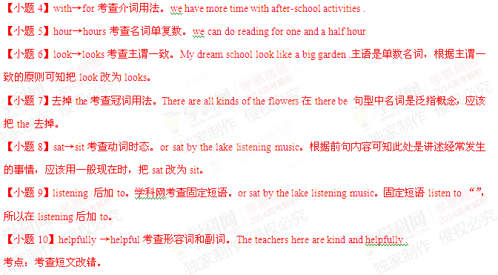【结束】
第二节 书面表达（满分25分）
【题文】 一家英语报社向中学生征文，主题是“十年后的我”，请根据下列要点和你的畅想完成短文。
1.家庭：
2．工作：
3.业余生活。
注意：1.词数100左右：
2.可以适当增加细节，以使行文连贯：
3.开头语已为你写好。
【解析】
【结束】

