试卷类型：B
2014年普通高等学校招生全国统一考试(新课标I)
英 语
注意事项：
1. 本试卷分第Ⅰ卷（选择题）和第Ⅱ卷（非选择题）两部分。第Ⅰ卷1页至10页，第Ⅱ卷11页至13页。
2. 答题前，考生务必将自己的姓名，准考证号填写在本试卷相应的位置。
3. 全部答案在答题卡上完成，搭载本试卷上无效。
4. 第Ⅰ卷听力部分满分30分，不计入总分，考试成绩录取时提供给高校作参考。
5. 考试结束后，将本试卷和答题卡一并交回。
第Ⅰ卷
第一部分 听力（共两节，满分30分）
做题时，现将答案标在试卷上，录音内容结束后，你将有两分钟的时间将试卷上的答案转涂到答题卡上。

- （共5小题；每小题1.5分，满分7.5分）
听下面5段对话，每段对话后有一个小题。从题中所给的A,B,C三个选项中选出最佳选项，并标在试卷的相应位置。听完每段对话后，你都有10秒钟的时间来回答有关小题和阅读下一小题。每段对话仅读一遍。
例： How much is the shirt?
- £ 19.15 B.£ 9.18 C.£ 9.15
答案是C。
1.What does the woman want to do ?
A. Find a place B. Buy a map C.Get an address
2. What will the man do for the woman?
A. Repair her car B.Give her a ride C.Pick up a aunt
3. Who might Mr Peterson be?
A. new professor B.A department head C.A company director
4. What does the man think of the book?
A.Quite different B.Very interesting C.Too simple
5.What are the speakers talking about?
A.Weather B.Clothes. C.News.
第二节（共15小题；每小题1.5分，满分22.5分）
听下面5段对话。每段对话或独白后有几个小题，从题中所给的、B、C三个选项中选出最佳选项，并标在试卷的相应位置。听每段对话或独白前，将有时间阅读各个小题，每小题5秒钟；听完后，各小题给出5秒钟的作答时间。每段对话或独白读两遍。
听第6段材料，回答第6、7题。
6.Why is Harry unwilling to join the woman?
A.He has a pain in his knee.
B.He wants to watch TV.
C.He is too lazy.
7.What will the woman probably do next?
A.Stay at home. B.Take Harry to hospital. C.Do some exercise.
听第7段材料，回答第8、9题。
8.When will the man be home from work?
A.At 5:45. B. At 6:15. C. At 6:50.
9.Where will the speaker go?
A.The Green House Cinema.
B.The New State Cinema.
C.The UME Cinema.
听第8段材料，回答第10至12题。
10.How will the speakers go to New York?
A.By air. B. By taxi. C. By bus.
11.Why are the speakers making the trip?
A.For business. B. For shopping. C. For hoilday.
12.What is the probable relationship between the speakers?
A.Driver and passenger. B. Husband and wife. C. Fellow workers.
听第9段材料，回答第13至16题。
13. Where does this conversation probably take place?
A. In a restaurant. B. In an office. C. In a classroom.
14. What does John do now?
A. He’s a trainer. B. He’s a tour guide. C. He’s a college student.
15. How much can a new person earn for the first year?
A. $10,500. B. $12,000. C. $15,000.
16. How many people will the woman hire?
A. Four. B. Three. C. Two.
听第10段材料，回答第17至20题。
17.How long has the speaker lived in a big city?
A. One year. B. Ten years. C. Eighteen years.
18. What is the speaker’s opinion on public transport?
A. It’s comfortable. B. It’s time-saving. C. It’s cheap.
19. What is good about living in a small town?
A. It’s safer. B. It’s healthier. C. It’s more convenient.
20. What kind of life does the speaker seem to like most?
A. Busy. B. Colorful. C. Quiet.
第二部分 阅读理解（共两节，满分60分）
- （共15小题；每小题3分，满分45分）
阅读下列短文，从每题所给的四个选项（A、B、C、和D）中，选出最佳选项，并在答题卡上将该项涂黑。
A
The Cambridge Science Festival Curiosity Challenge
Dare to Take the Curiosity Challenge!
The Cambridge Science Festival (CSF) is pleased to inform you of the sixth annual Curiosity Challenge. The challenge invites, even dares school students between the ages of 5 and 14 to create artwork or a piece of writing that shows their curiosity and how it inspires them to explore their world.
Students are being dared to draw a picture, write an article, take a photo or write a poem that shows what they are curious about. To enter the challenge, all artwork or pieces of writing should be sent to the Cambridge Science Festival, MIT Museum, 265 Mass Avenue. Cambridge 02139 by Friday, February 8th.
Students who enter the Curiosity Challenge and are selected as winners will be honored at a special ceremony during the CSF on Sunday, April 21st. Guest speaker will also present prizes to the students. Winning entries will be published in a book. Student entries will be exhibit and prizes will be given. Families of those who take part will be included in the celebration and brunch will be served.
Between March 10th and March 15th, each winner will be given the specifics of the closing ceremony and the Curiosity Challenge celebration. The program guidelines and other related information are available at: http://cambridgesciencefestival.org.
【小题1】 Who can take in the Curiosity Challenge?
A. School students.
B. Cambridge locals.
C. CSF winners.
D. MIT artists.
【小题2】 When will the prize-giving ceremony be held?
A. On February 8th.
B. On March 10th
C. On March 15th..
D. On April 21st.
【小题3】What type of writing is this text?
A. An exhibition guide.
B. An art show review.
C. An announcement.
D. An official report.
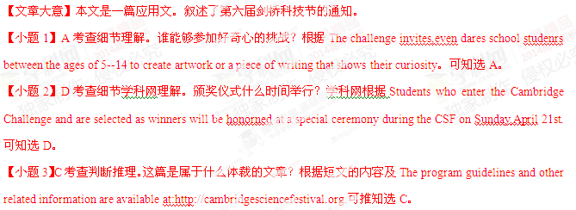 B
Passenger pigeons（旅鸽）once flew over much of the United States in unbelievable numbers. Written accounts from the 18th and 19th centuries described flocks（群）so large that they darkened the sky for hours.
It was calculated that when its population reach its highest point, there were more than 3 billion passenger pigeons – a number equal to 24 to 40 percent of the total bird population in the United States, making it perhaps the most abundant birds in the world. Even as late as 1870 when their numbers had already become smaller, a flock believed to be 1 mile wide and 320 miles (about 515 kilometers) long was seen near Cincinnati.
Sadly, the abundance of passenger pigeons may have been their undoing. Where the birds were abundant, people believed there was an ever-lasting supply and killed them by the thousands. Commercial hunters attracted them to small clearings with grain, waited until pigeons had settled to feed, then threw large nets over them, taking hundreds at a time. The birds were shipped to large cities and sold in restaurants.
By the closing decades of the 19th century, the hardwood forests where passenger pigeons nested had been damaged by Americans’ need for wood, which scattered（驱散）the flocks and forced the birds to go farther north, where cold temperatures and spring storms contributed to their decline. Soon the great flocks were gone, never to be seen again.
In 1897, the state of Michigan passed a law prohibiting the killing of passenger pigeons, but by then, no sizable flocks had been seen in the state for 10 years. The last confirmed wild pigeon in the United States was shot by a boy in Pike County, Ohio, in 1900. For a time, zxxk.coma few birds survived under human care. The last of them, known affectionately as Martha, died at the Cincinnati Zoological Garden in September 1, 1914.
【小题1】 In the 18th and early 19th centuries, passenger pigeons _______.
A. were the biggest bird in the world B. lived mainly in the south of America
C. did great harm to the natural environment D. Were the largest population in the US
【小题2】The underlined word “undoing” probably refers to the pigeons’ _______.
A. escape B. ruin C. liberation D. evolution
【小题3】What was the main reason for people to kill passenger pigeons?
A. To seek pleasure. B. To save other birds.
C. To make money. D. To protect crops.
【小题4】 What can we infer about the law passed in Michigan?
A. It was ignored by the public. B. It was declared too late.
C. It was unfair. D. It was strict.
【文章大意】本文是一篇记叙文。叙述了旅鸽逐渐消失的过程。
【小题1】D. 考查细节理解。在18世纪和19世纪初期，旅鸽的数量怎么样？根据Passenger pigeons（旅鸽） C
A typical lion tamer (驯兽师) in people’s mind is an entertainer holding a whip (鞭子)and a chair .The whip get all of the attention , but it’s mostly for show .In reality , it’s the chair that does the important work .When a lion tamer holds a chair in front of the lion’s face , the lion tries to focus on all four legs of the chair at the same time .With its focus divided , the lion becomes confused and is unsure about what to do next .When faced with so many options , the lion chooses to freeze and wait instead of attacking the man holding the chair.
How often do you find yourself in the same position as the lion ? How often do you have something you want to achiever (e,g. lose weight , start a business , travel more ) –only to end up confused by all of the options in front of you and never make progress ?
This upsets me to no end because while all the experts are busy debating about which option is best , the people who want to improve their lives are left confused by all of the conflicting information .The end result is that we feel like we can’t focus or that we’re focused on the wrong things , and so we take less action , make less progress , and stay the same when we could be improving .
It doesn’t have to be that way .Anytime you find the world waving a chair in your face , remember this :All you need to do is focus on one thing .You just need to get started .Starting before you feel ready is one of the habits of successful people .If you have somewhere you want to go , something you want to accomplish , someone you want to become ….take immediate action .If you’re clear about where you want to go , the rest of the world will either help you get there or get out the way .
【小题1】 Why does the lion tamer use a chair?
A. To trick the lion.
B. To show off his skill .
C. To get ready for a fight.
D. To entertain the audience.
【小题2】 In what sense are people similar to a lion facing a chair?
A. They feel puzzled over choices.
B. They hold on to the wrong things.
C. They find it hard to make changes.
D. They have to do something for show.
【小题3】 What is the author’s attitude towards the experts mentioned in paragraph 3?
A. Tolerant
B. Doubtful
C. Respectful
D. Supportive
【小题4】 When the world is “waving a chair in your face”, you’re advised to_____.
A. wait for a better chance
B. break your old habits
C. make a quick decision
D. ask for clear guidance
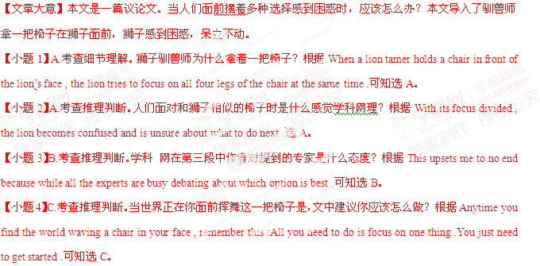D
As more and more people speak the global languages of English, Chinese, Spanish, and Arabic, other languages are rapidly disappearing. In fact, half of the 6,000-7,000 languages spoken around the world today will likely die out by the next century, according to the United Nations Educational, Scientific, and Cultural Organization (UNESCO).
In an effort to prevent language loss, scholars from a number of organizations- UNESCO and National Geographic among them –have for many years been documenting dying languages and the cultures they reflect.
Mark Turin, a scientist at the Macmillan Center, Yale University, who specializes in the languages and oral traditions of the Himalayas, is following in that tradition. His recently published book, A Grammar of Thangmi with an Ethnolinguistic Introduction to the Speakers and Their Culture, grows out of his experience living, looking and raising a family in a village in Nepal.
Documenting the Tangmi language and culture is just a starting point for Turin, who seeks to include other languages and oral traditions across the Himalayans reaches of India, Nepal, Bhutan, and China. But he is not content to simply record these voices before they disappear without record.
At the University of Cambridge Turin discovered a wealth of important materials- including photographs, films, tap recordings, and field notes- which had remained unstudied and were badly in need of care and protection.
Now, through the two organizations that he has founded-the Digital Himalaya Project and the World Oral Literature Project- Turin has started a campaign to make such documents, found in libraries and stores around the world, available not just to scholars but to the youngers.
Generations of communities from whom the materials were originally collected.Thanks to digital technology and the widely available Internet. Turin notes,the endangered languages can be saved and reconnected with speech communities.
【小题1】Many scholars are making efforts to _____.
- promote global languages
- rescue the disappearing languages
- search for language communities
- set up languages research organizations.
【小题2】What does “that tradition” in Paragraph 3 refer to?
- Having first records of the languages
- Writing books on language searching
- Telling stories about language users
- Linking with the native speakers
【小题3】What is Turin’s book based on?
- The cultural statics in India.
- The documents available at Yale.
- His language research in Britain.
- His personal experience in Nepal.
【小题4】Which of the following best describe Turin’s Work?
- Write sell and donate.
- Record,repeat and reward.
- Collect,protect and reconnect.
- Design, experiment and report.
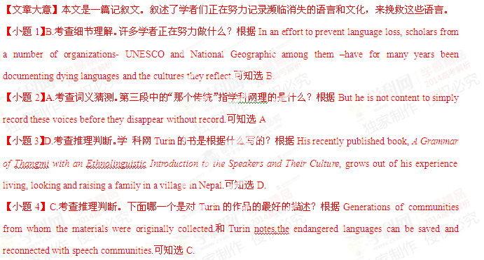第二节 （共3小题，每小题3分，满分15分）
根据短文内容，从短文后的选项中选出能填入空白处的最佳选项，选项中有两项为多余选项。
The jobs of the future have not been invented, 36 By helping them develop classic skills that will serve them well no matter what the future holds.
1. Curiosity
Your children need to be deeply curious. 37 Ask kids, “What ingredients (配料) can we add to make these pancakes even better next time” and then try them out. Did those ingredients make the pancakes better? What could we try next time?
2. Creativity
True creativity is the ability to take something existing and create something new from it. 38 There are a dozen different things you can do with them. Experimenting with materials to create something new can go a long way in helping them develop their Creativity.
3. Interpersonal Skills
Understanding how others feel can be a challenge for kids. We know what is going on inside our own head, but what about others? Being able to read people helps kids from misreading a situation and jumping to false conclusions. 39 “Why do you think she is crying?” “Can you tell how that man is feeling by looking at his face?” “If someone were to do that to you, how would you feel?”
4. Self Expression
40 There are many ways to express thoughts and ideas ¡ª music, acting, drawing, building, photography. You may find that your child is attracted by one more than another.
A. Encourage kids to cook with you.
B. And we can’t forget science education.
C. We can give kids chances to think about materials in new ways.
D. So how can we help our kids prepare for jobs that don’t yet exist?
E. Gardening is another great activity for helping kids develop this skill.
F. We can do this in real life or ask questions about characters in stories.
G. Being able to communicate ideas in a meaningful way is a valuable skill.
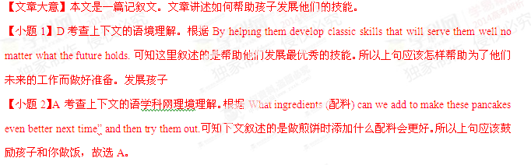【小题3】C 考查上下文的语境理解。学科 网根据True creativity is the ability to take something existing and 第三部分 英语知识运用（共两节， 满分55分）
- 完形填空（共20 小题；每小题两分，满分40分）
阅读下面短文，从短文后各题所给的四个选项（A, B, C, D）中，选出可以填入空白处的最佳选项，并在答题卡上将该项涂黑。
As a general rule, all forms of activity lead to boredom when they are performed on a routine basis. As a matter of fact, we can see this ____41____at work in people of all _____42____. For example, on Christmas morning, children are excited about ___43____with their new toys. But their ___44_____soon wear off and by January those_____45____toys can be found put away in the basement. The world is full of_____46____stamp albums and unfinished models, each standing as a monument to someone’s ____47_____interest. When parents bring home a pet, their child____48____bathes it and brushes its fur. Within a short time, however, the___49____of caring the animal is handed over to the parents. Adolescent enter high school with great____50___but soon looking forward to_____51___. The same is true of the young adults going to the college. And then, how many____52_____, who complain about the long drives to work, ____53_____drove for hours at a time when they first_____54____ their drivers licenses? Before people retire, they usually ___55____to do a lot of___56__things, which never had __57___while working. But ____58____after retirement, the golfing, the fishing , the reading and all of the other pastimes become as boring as the jobs they ___59____. And, like the child in January, they go searching for new____60_____.
【小题1】A.principle B.habit C.way D.power
【小题2】A.parties B.races C.countries D.ages
【小题3】A.working B.living C.playing D.going
【小题4】A.confidence B.interest C.anxiety D.sorrow
【小题5】A.same B.extra C.funny D.expensive
【小题6】A.well-organized B.colorfully-printed C.newly-collected D.half-filled
【小题7】A.broad B.passing C.different D.main
【小题8】A.silently B.impatiently C.gladly D.worriedly
【小题9】A.promise B.burden C.right D.game
【小题10】A.courage B.calmness C.confusion D.excitement
【小题11】A.graduation B.independence C.responsibility D.success
【小题12】A.children B.students C.adults D.retirees
【小题13】A.carefully B.eagerly C. nervously D.bravely
【小题14】A.required B.obtained C.noticed D.discovered
【小题15】A.need B.learn C.start D.plan
【小题16】A.great B.strange C.difficult D.correct
【小题17】A.time B.money C.skills D.knowledge
【小题18】A.only B.well C.even D.soon
【小题19】A.lost B.choose C.left D.quit
【小题20】A.pets B.toys C.friends D.colleagues
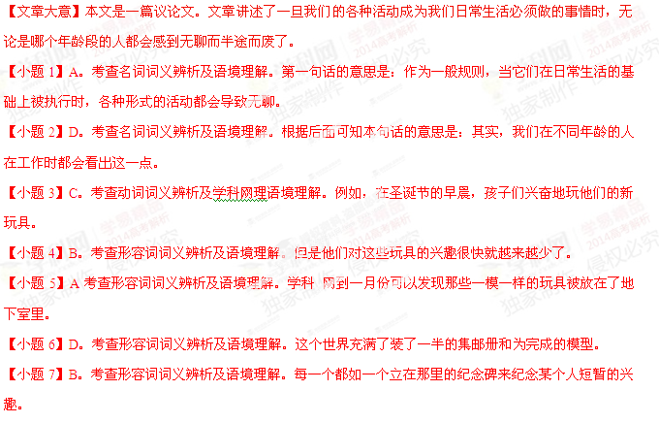【小题8】C。考查副词词义辨析及语境理解。当父母带回家一只宠物，他们的孩子高高兴兴地给它洗澡、给它刷毛。
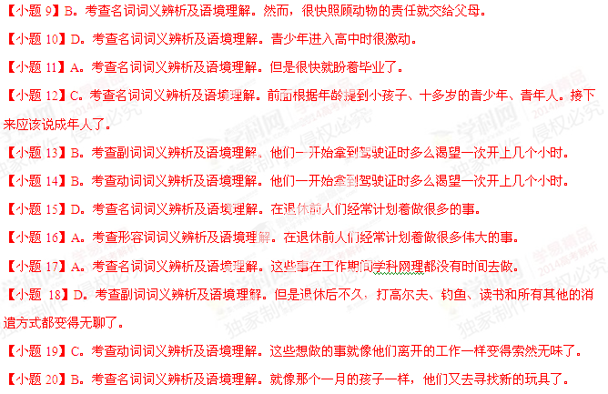第II卷
第三部分 英语知识运用（共两节 满分55）
- 阅读下面材料，用不多于3个单词的正确形式填空
Are you facing a situation that looking impossible to fix?
In 1969, the pollution is terrible along the Cuyahoga River near Cleveland, Ohio. It ______61(be)imaginable that it could be ever be cleaned up. The rive was so polluted that it ______62(actual) caught fire and burned. Now year late,this rive is one of_______63most outstanding examples of environmental cleanup.
But river wasn’t changed in a few days_____64even a few months. It took years of work _______65(reduce) industrial pollution and clean the water. Finally, that hard work paid off and now the water in the river is______66(clean) than ever.
Maybe you are facing an impossible situation. Maybe you have a habit _____67 is driving your family crazy. Possibly you drink too much or don’t know how to control your credit card use. When you face such impossible situation, don’t you want a quick fix and something to change immediately.
While there are_______68(amaze) stories of instant transformation, for most of us the _______69(change) are gradual and require a lot of effort and work, like cleaning up a polluted river. Just be_______70(patience)
【文章大意】本文是一篇议论文。文中论述了当人们遇到看起来不可能做的事情时应该怎样做呢？
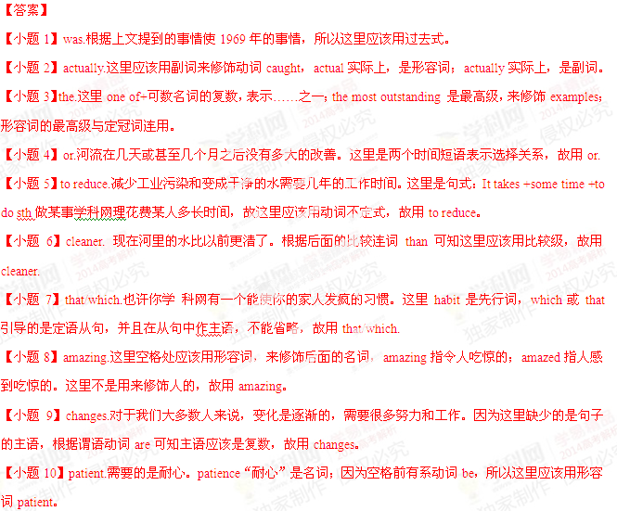第四部分 写作 （共两节 满分35）
- 短文改错（10分）
Nearly five years before, and with the help by our father, my sister and I planted
Some cherry tomatoes(圣女果)in our back garden. Since then- for all these years-we
had been allowing tomatoes to self-seed where they please. As result, the plants are
growing somewhere. The fruits are small in size,but juicy and taste. There are so much
that we often share them with our neighbors. Although we allow tomato plants to grow
in the same place year after year, but we have never had any disease or insect attack
problems. We are growing wonderfully tomatoes at no cost!
【答案】
【小题1】before—ago
【小题2】by—of
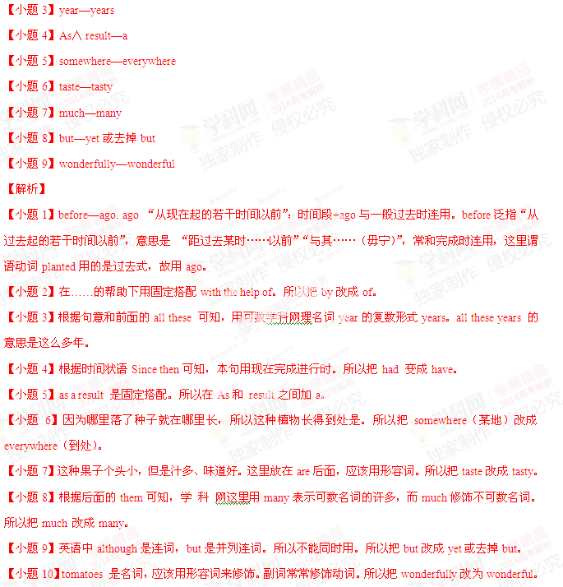书面表达
假如你是李华，计划暑假期间去英国学习英语为期六周。下面的广告引起了你的注意。请给该校写一封信，询问有关情况。（箭头所指内容）
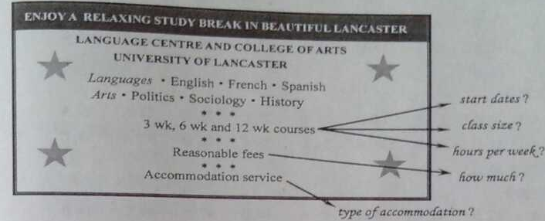
注意：1.词数100左右
2.可以适当增加细节，以使行文流畅。
- 参考词汇：住宿—accommodation
